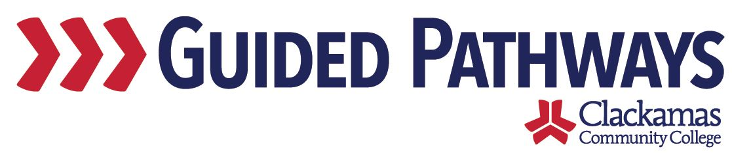
Guided Pathways Leadership Taskforce
Meeting Notes
April 6, 2020, 2:00–3:30 p.m. (Zoom)

- Follow up on previous commitments and updates
Commitments were reviewed.
- No updates on any existing commitments

- GPTF Timeline Activity
Carol engaged the taskforce members in an activity. Taskforce member shared their ideas and concerns:
- Sue discussed integration with pre-college
- Nora discussed the idea of a new class
- Lisa R. discussed new intro courses that need to work their way through Curriculum Committee this term – suggested having faculty from this group help make sure that moves forward

Max engaged the group in a breakout activity with a Google doc, breaking everyone out into four breakout groups (each group had their own tab in the document). The groups were asked to fill in as much of the list of projects as possible.

Max and Carol are going to look through the Google doc and synthesize what was included. Max invited taskforce members to feel free to continue updating the doc, even after the meeting.

- FYE Logistics and Opt-Out Options
Lupe Martinez provided updates on the progress of FYE. She said that there are 30 sections planned for fall 2020. These include 27 sections at Oregon City, two sections at Harmony, and one online section. Fall 2020 will be a test term to see what adjustments need to be made for fall 2021. If enrollment persists, they anticipate needing 60 sections for fall 2021. A part-time faculty counselor, Alphonso Nunez, has been assigned as the FYE Liaison. Lupe discussed adjacency of the classrooms. Two classrooms will be necessary for fall 2020 and they will need approximately four classrooms in fall 2021. Lupe discussed the ongoing question of who will be the gatekeeper for enforcing FYE and keeping track of the exceptions.

Taskforce members asked questions:
- Max asked if FYE will be required for fall 2020. It will not be required, but strongly recommended. It will be a requirement for fall 2021.
- David asked if there were any changes made to the course. Lupe said that the only changes that are made are as a result of the assessment process. The content is the same as we’ve had for the last 3-4 years.
- Dawn asked if a section of FYE could be offered in Spanish. Lupe said that there are staff in the department that are bilingual, fluent, and bicultural, so this could be offered. However, if the program of study isn’t offered in Spanish, perhaps it would be incongruent if the degree wasn’t offered entirely in Spanish.

Lupe said that there is an FAQ sheet for FYE. She will send that FAQ to Sara so that Sara can send to the taskforce.

- EFA Webpages
Lori provided updates on the EFA webpages. She shared the preliminary template for the EFA webpages. She said that content is being added and the pages will be reviewed with EFA Development Network. Lori said that eventually they’d like to have a video included for each EFA.

- Workgroup updates
Max said that the group that is setting up the application for the EFAs as well as primary/secondary programs would like feedback from the taskforce. For current students, in the last five years, we want to know when we should be surveying those students to figure out what their primary program is – when should that survey to current students (active in the last five years) happen? Dawn said that the sooner we have that information, the better. Jennifer agreed. Max will take this information back to that group.

- Review commitments and next steps
Commitments and next steps were reviewed. The next Guided Pathways Taskforce Meeting is on Monday, May 4, 2:00–3:30 p.m.

